

Add comment

**ICT Core Content Notes - Month 3 @arjoio**

**D** Timeframe Selection & Defining Setups

**D** Institutional Order Flow

**El** Institutional Sponsorship

**a** Anticipatory Skill Development

**El** Institutional Market Structure

**0** Macro Economic To Micro Technical

**fJ** Market Maker Trap Trendline Phantoms

I] Market Maker Trap Head Shoulders Pattern

**T *PDF notes***

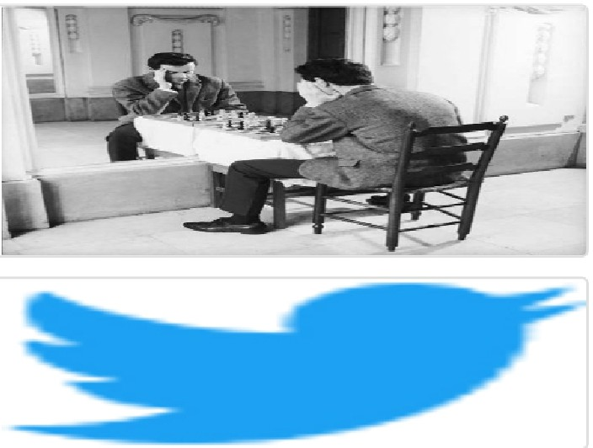Arjo I Twitter, lnstagram I Linktree

Linktree. Make your link do more.

, https://t.co/HhmmTN1fUI

JavaScript is not available.

https:/ltwitter.com/arjoio